**How to raise a credit note in Exerp**

1. Open up the member’s profile in Exerp > Select the Account tab
2. Select Credit Note

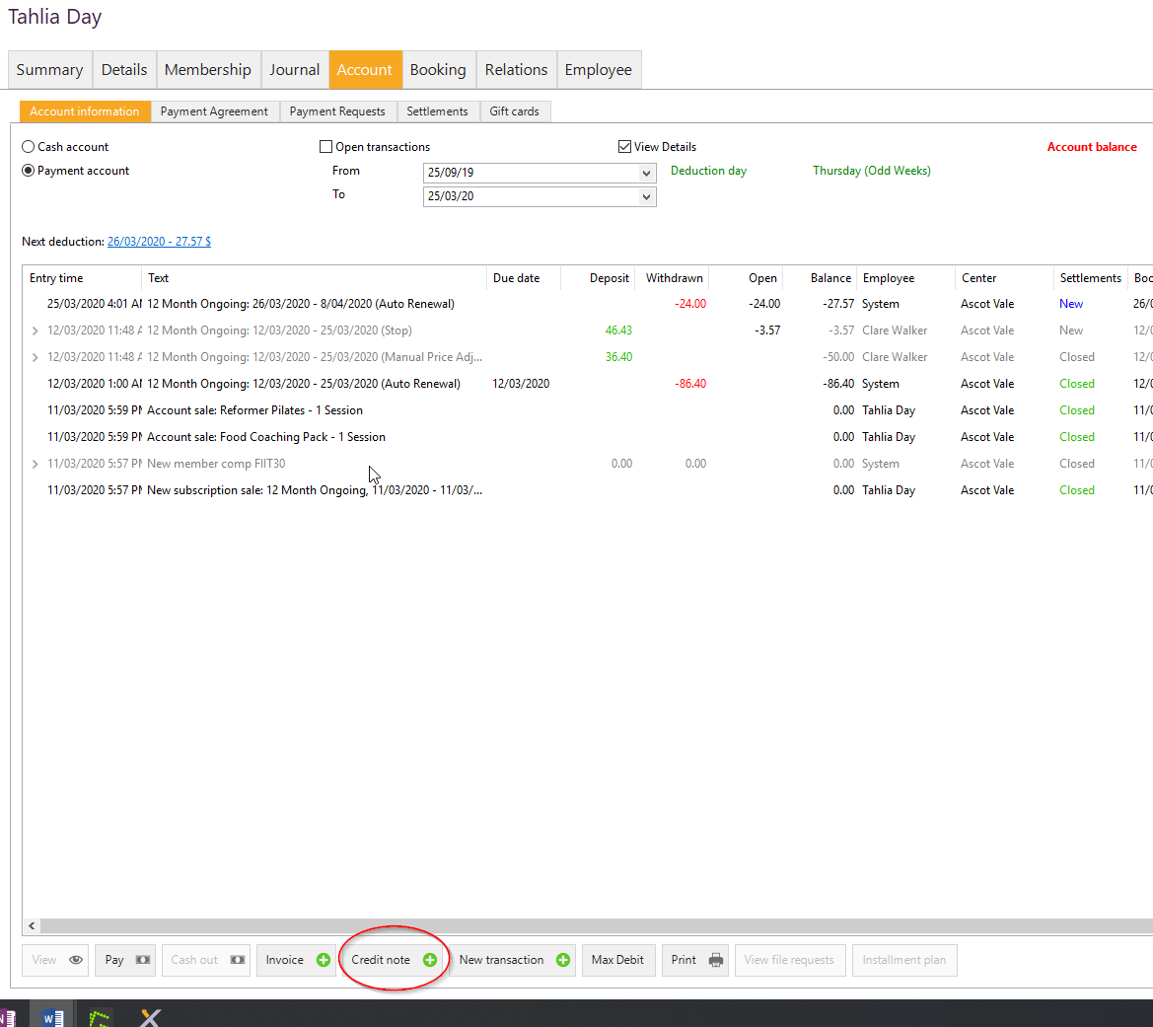

1. It auto-selects ‘Free Credit note’ > Select Next
2. Select New Credit Line
   1. In the Credit Product field type in ‘Membership Fee’ and select
   2. In the Cancel Type field – select ‘Wrong Sale’
   3. Enter the credit amount
   4. In the Credit Line field enter ‘COVID-19 Adjustment’
   5. In the Reason field – select ‘Goodwill’
   6. Select OK

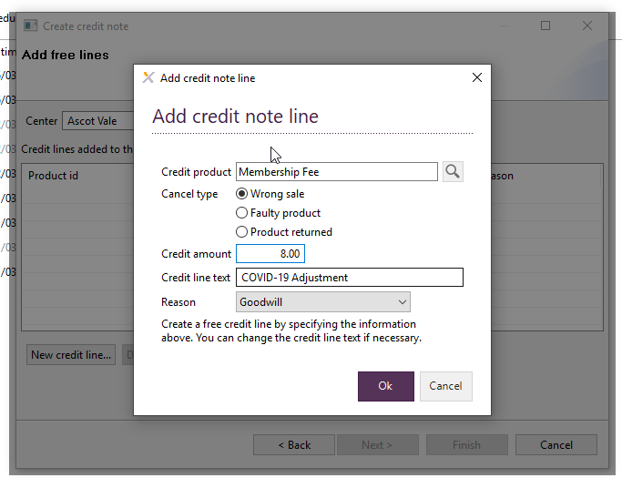

1. Select Next > Update the Header text to ‘COVID-19 Adjustment’ > Enter the reason for the credit note e.g. COVID-19 Adjustment > Select Next

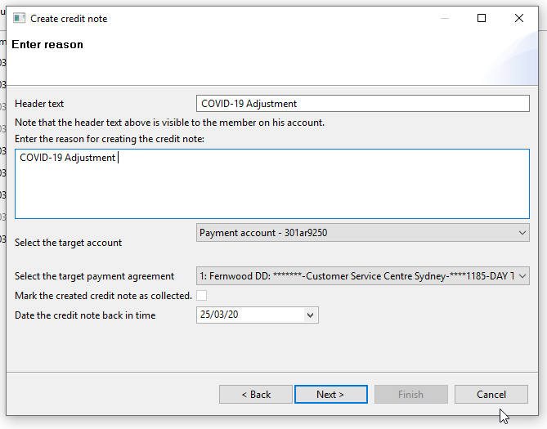

1. Review summary and select Next
2. In the Payout window > Select ‘Leave at customers account’ > Select Finish

